Web Development – Activity Based Learning
  - Name: A. Sai Karthik
  - Roll No: 26001125
  - Section: CSM-05

1.My Portfolio Website HTML Code:
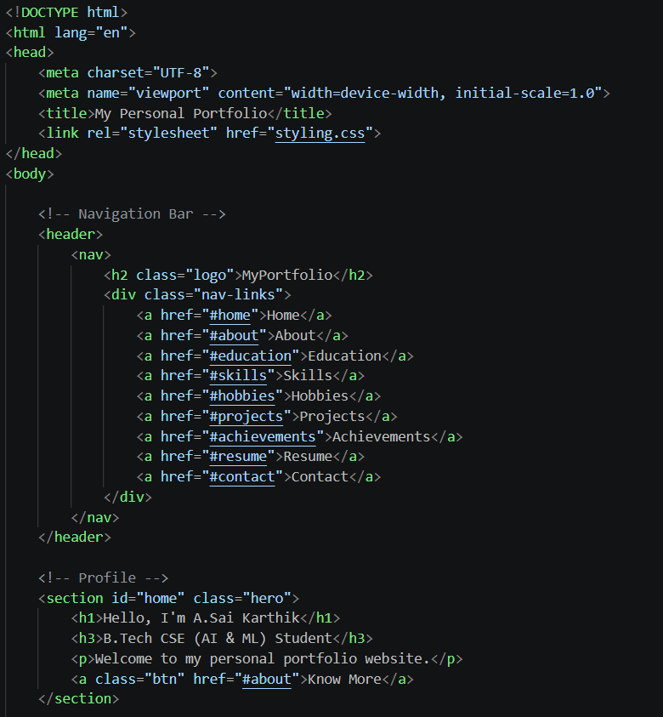

CSS Code:
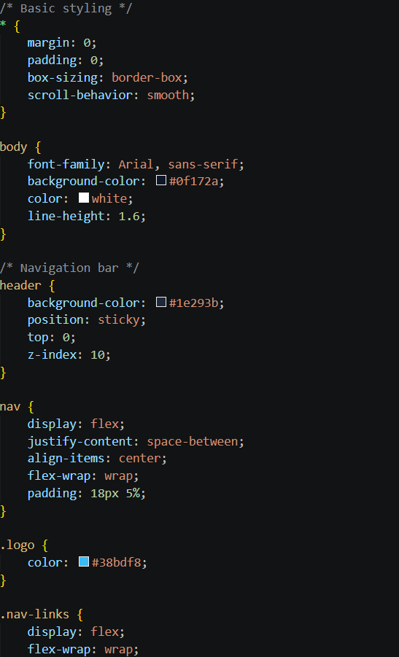

Output:

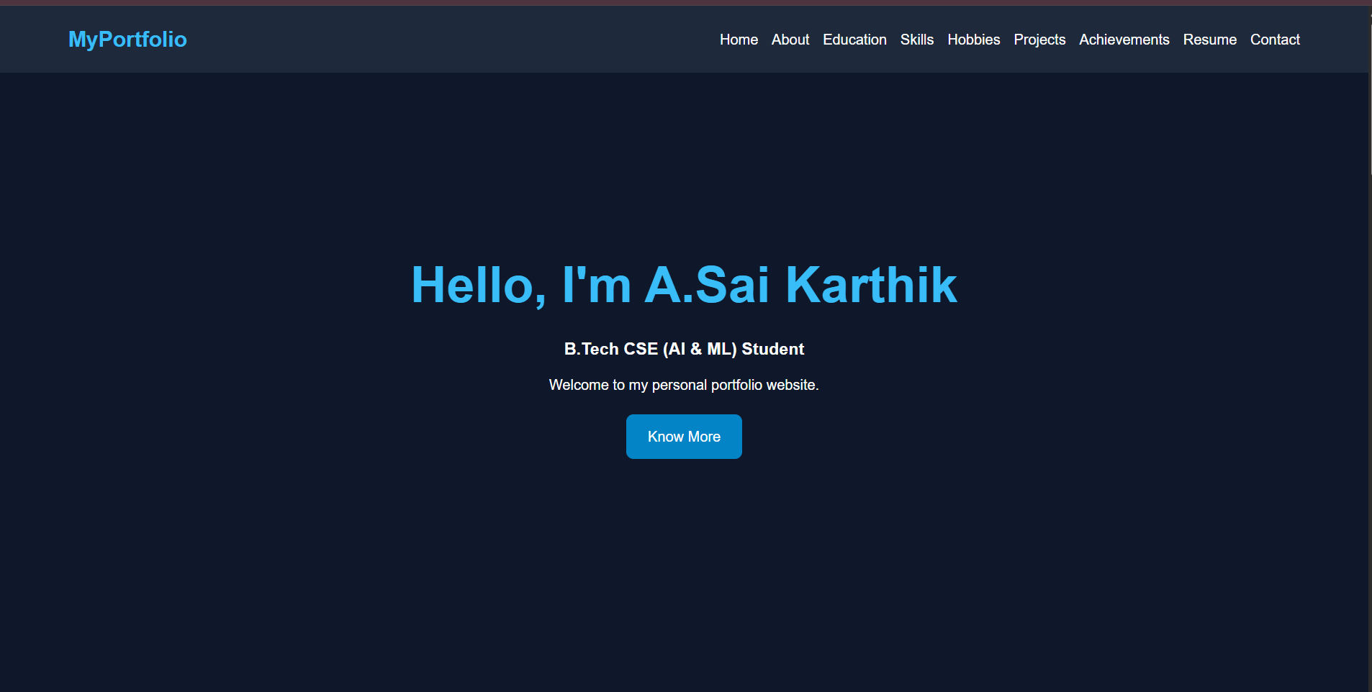

Explanation:
1.The above website is Written using basic HTML and CSS Code

2.No Java Script is used for the building of above website

3.In the above website Home navigates to a page which shows the details of the person

4.About navigates to the persons identity, studies and schooling

5.Education, Skills, Projects and Achievements tell about his standards and discipline

2.My College Website

HTML Code:
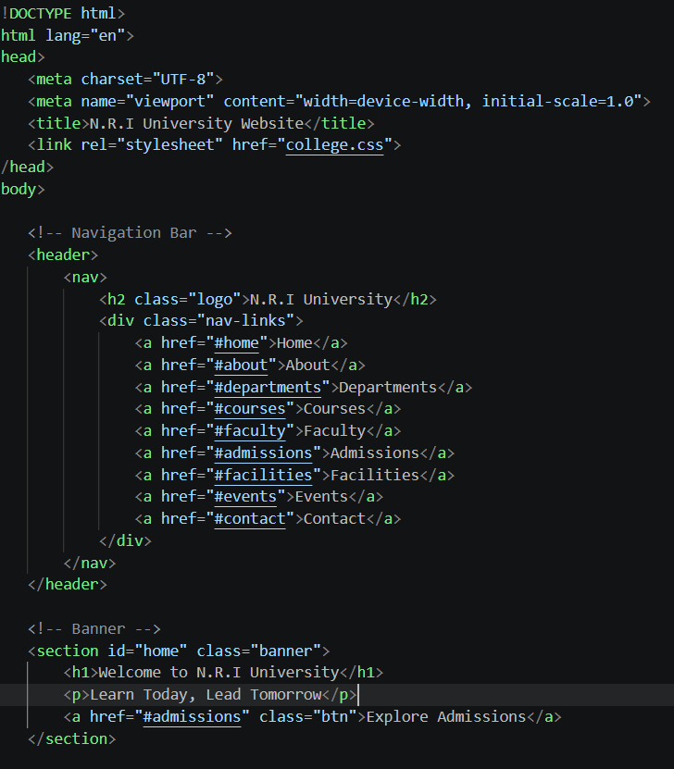

CSS Code:

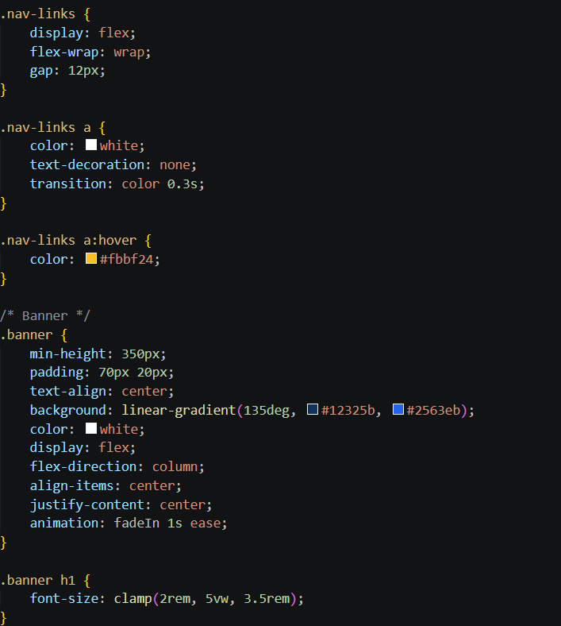

Explanation:
1.The above website is built using basic HTML code and CSS code
2.The about navigates to the main page of the College Website
3.The Courses and skills offered navigates and tell about the courses offered in the college and the skills trained by the faculty in the college.
4.The contact navigates to the official contact phone number of the college.

Output:
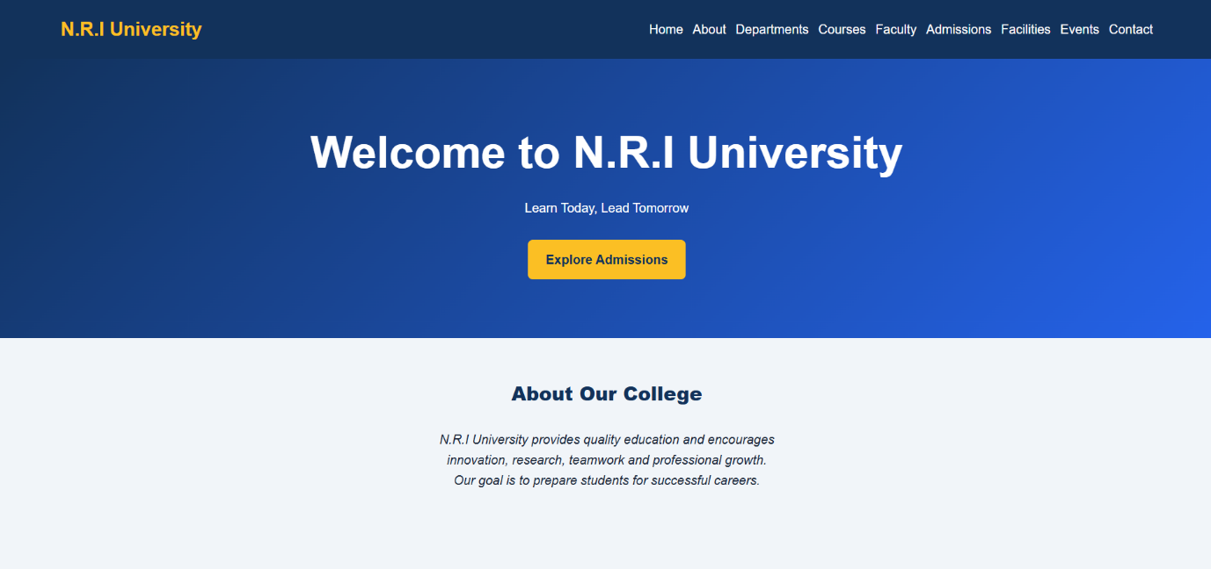

3. My E-Mart Website

HTML Code:
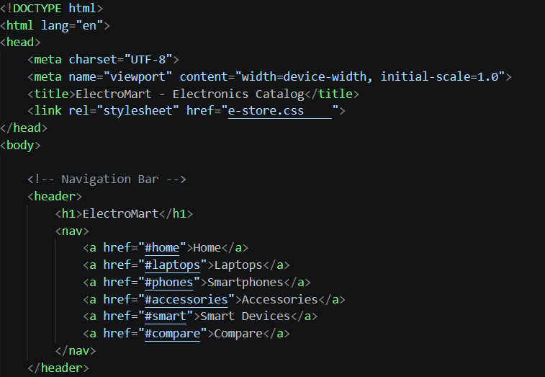

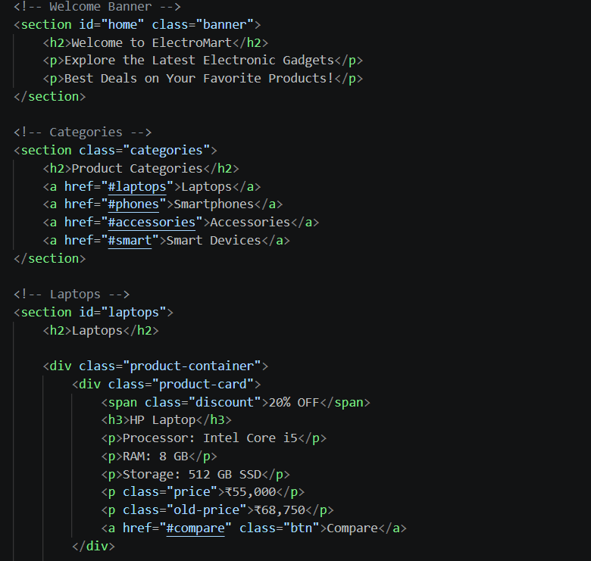
CSS Code:
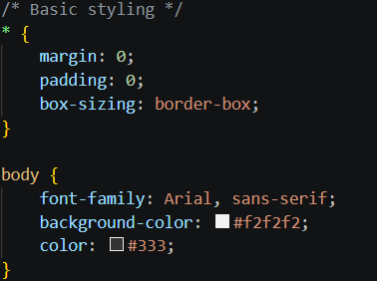

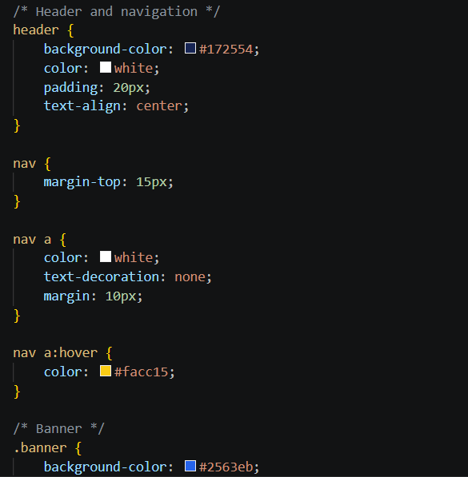

Output:
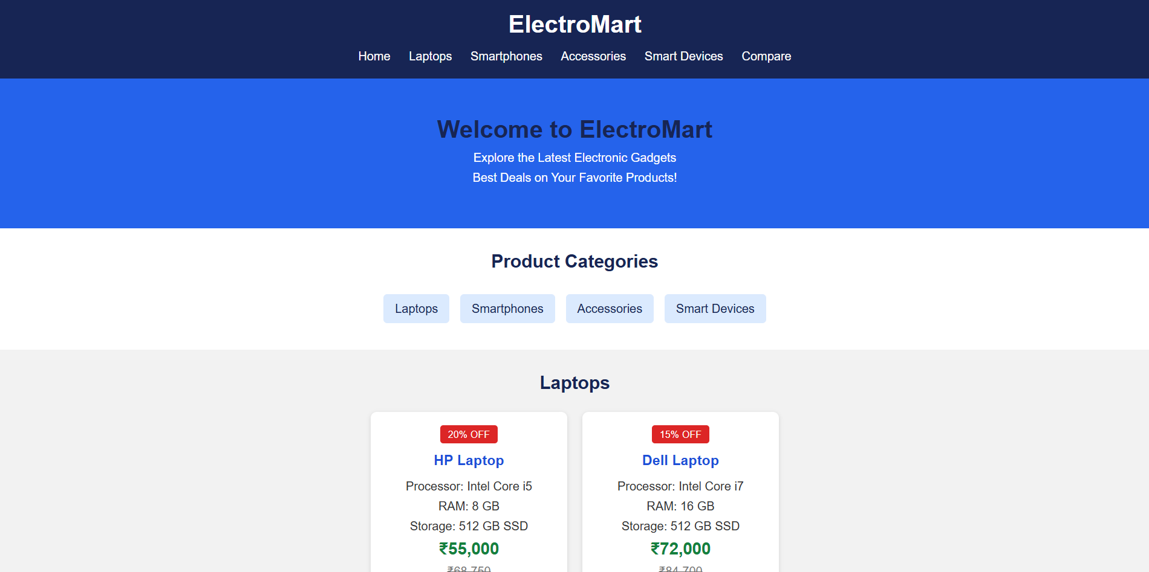

Explanation:
1.This website is built using basic HTML and CSS code
2.The home navigates to the main page of the e-mart website
3.Compare navigates to a page in which the prices of two laptops or smartphones are being compared and tells the best choice
4.Accessiories navigates to other electronics page

3 Case studies are built

1.My Portfolio Website
Objective: To create a personal branding site showcasing skills, projects, resume, and contact information.
Key Features: About Me, Skills, Projects Gallery, Contact Form, Responsive Design.
Pages: index.html, about.html, projects.html, contact.html

2.My College Website
Objective: To develop an informational website for a college.
Key Features: Department listings, Admission info, Events, Faculty profiles, Notice board.
Pages: Home, Departments, Admissions, Events, Faculty

3.My Electromart Website
Objective: To build a product catalog for electronics (not full e-commerce, but a showcase).
Key Features: Product categories, Product details, Search/Filter, Comparison table.
Technologies can be extended with JavaScript for interactivity.

Technologies Used:

1.HTML5: Structure and semantic markup for all case studies
2.CSS3: Styling, layout (Flexbox/Grid), responsiveness and animations

Conclusion:
All of the above outputs are the test cases of Activity Based Learning of Web Development.

